Week 9 Newsletter – 15th December 2021
Kia ora Mahora Whānau,

This will be the final newsletter for 2021.

Farewell
This week we farewell 4 of our special staff. Each of these staff have contributed so much to our school and we thank them for their commitment and passion with our learners.

- Tanya Calitz is leaving on maternity leave for 2022 to have her first child. Tanya we wish you and Fraser all the best with this exciting chapter ahead.
- Emma Fatialofa has completed her fixed term contract and will spend some more time as ‘mum’ and with her whānau. Full time teaching with a young family is hard work…especially as a mum!! (said with full respect from a dad!!)
- Emma McKay has completed her fixed term contract and is leaving to explore the area of sustainability with the hope of returning to education and to develop this area further. An exciting learning time ahead Emma.
- Dee Whitby is retiring from education after a phenomenal 45 years in education. Dee has established our Learning Support role so well and has had such a supportive impact on students, staff and whanau. Thank you Dee for your amazing passion and skill. 45 years of service is simply outstanding. Dee has a precious granddaughter, who is very much looking forward to being the centre of attention!
Piki Haere and ngā mihi to you all.
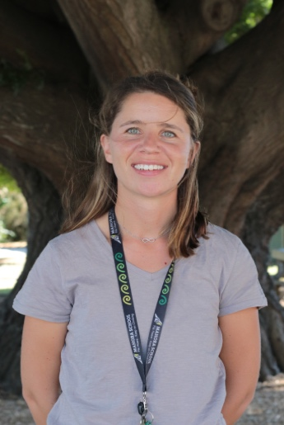
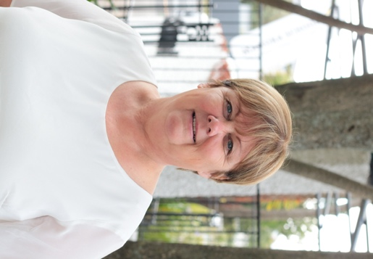

Prize-giving
We had a wonderful evening on Monday night and the live stream worked perfectly! Our Year 5’s and 6’s did us all proud. There will be a full update and photos shared on Facebook soon…here is a quick one of the Y6 cup recipients. Congratulations to all.
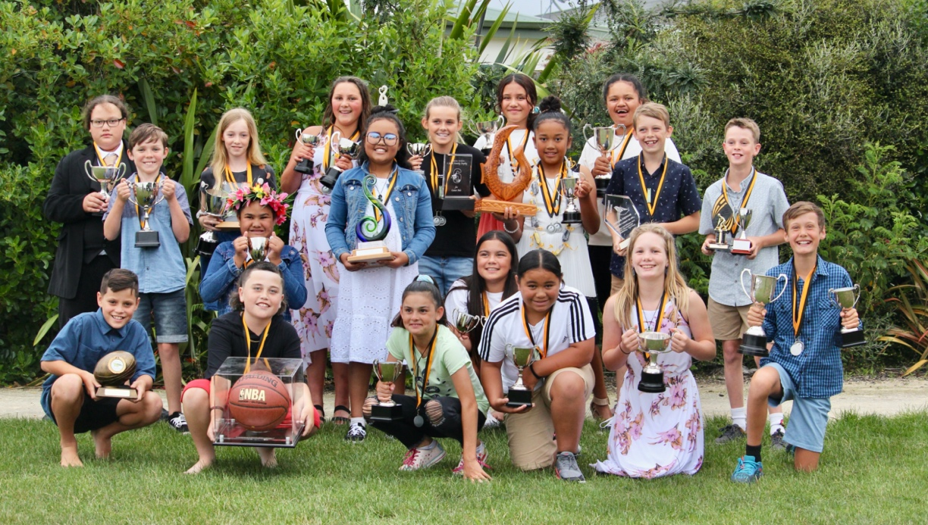

Lunches 2022
Next year we are changing our school lunch provider. We are excited to announce that we have been working with Jimmy Macken from Hastings Girls High School who will provide all lunches for Mahora children from 2022. We have been sampling some of them and trust me…they are wonderful! Jimmy has been a long time caterer, so knows catering like the back of his hand. Prior to this he set up and owned Bareknuckle BBQ, so he comes highly recommended.

Jimmy will be looking for more staff to support this growth and is always keen to employ local community members. If you would like more information please contact him via jim@hastingsgirls.com

We know some parents have removed their children from the free school lunches system. If you would like to reinstate this for your child, please email Kirsten via kirstenw@mahora.school.nz

Covid 19 Information
The new Covid 19 guidelines for Mahora School were shared with you last week. Naturally this is based on what we know now. This can change so please ensure you are checking the school app and Facebook page before school starts next year. There will be more information to come, so you know what the process will be if there is a case at Mahora School. It is REALLY important all whānau know and understand this.
Reminders from last week’s newsletter…
Office hours to start the term
Wednesday 26th January 8am-4pm
Thursday 27th January Closed
Friday 28th January 8am-2pm
Monday 31st January 8am-6pm (is also Whanaungatanga Day)

Stationery
We are continuing with pre-packed stationery packs in 2022. All stationery for Mahora children must be purchased through our school office. We do not make any profit from the stationery, we simply pass the cost on. Pack costs in 2022 will be:

New Entrants (Junior Team) - $30 per child
Year 1 & 2 (Junior Team) - $25 per child
Year 3 & 4 (Middle Team) - $20 per child
Year 5 & 6 (Senior Team) - $15 per child

If you would like to pre-pay 2022 stationery now to save the cost next year, you can pay into the school bank account using your child’s name and ‘stationery’ as a reference, or if you have a credit on your school account please let Kirsten know by emailing her on kirstenw@mahora.school.nz Your child’s name will be recorded and they will be handed their new pack on day 1.

Class Connection/ Whanaungatanga Day – please refer to CPF guidelines in this newsletter
On Monday 31st January, all classes will be open from 1.00pm – 6.00pm for families to call in and visit with your child/children. The purpose of this important time is for any of the following:
- To explore each child’s new learning space for 2022
- To connect with 2022 teachers and staff
- For parents to ask any questions or share important information about their child
- To give our children the opportunity to reduce start of year worries and begin to make strong connections

To our school community and everyone that works here, volunteers, cares, contributes, helps or just supports in so many ways… my thanks to you all for caring about tamariki and whānau and the unlimited energy that has been needed again in 2021.
It is APPRECIATED.

To our staff – You have done a phenomenal job and stepped up yet again…thank you for the effort, the passion and the desire to do your very best right through 2021. Enjoy the time ahead with your own whānau.

To our community – I wish you all a wonderful festive season ahead and hope you all get some special time with your whānau. This time of year is all about the most special people in our lives…our family.

Piki Haere
Rohan and the Mahora Team

